Here is a brief description of the problem that I am experiencing.

- I created and packaged a course in Articulate Storyline 2. I don’t think anything is wrong with the packaging.

- Next I uploaded this packaged course in coursemill. However it is not playing at all. Here is a copy of the error message. Just for your information, I have created courses and uploaded many times in coursemill exactly the same way, and never had this problem.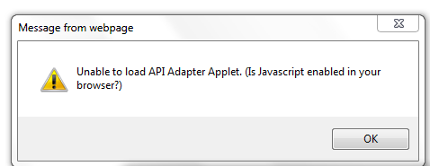

Do you know what could be happening?
Thanks,
Indrani

