- Inside course (content) that can be copied to another course
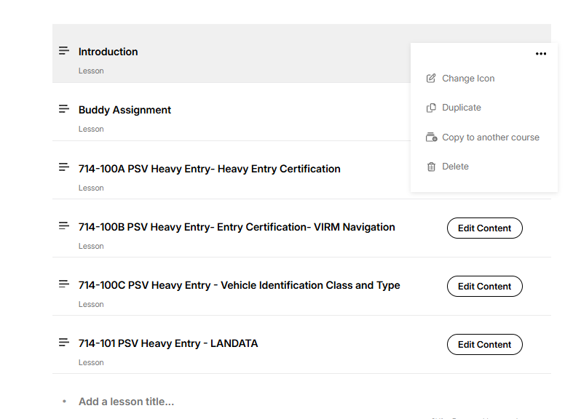

- Courses do not allow for the same tool / function (would be great to add a course to another course content
